

UNDERGRADUATE PROJECT PROGRESS REPORT

|  |  |
| --- | --- |
| **Project Title:** | **Federated** **Convolutional Generative Network for Next Item Recommendation** |
| **Surname:** | **Long** |
| **First Name:** | **Yicheng(Jack)** |
| **Student Number:** | **202018010116** |
| **Supervisor Name:** | **Joojo Walker** |
| **Module Code:** | **CHC 6096** |
| **Module Name:** | **Project** |
| **Date Submitted:** | **2023.12.25** |

**Table of Contents**

1 Introduction 3

1.1 Background 3

1.2 Aim 3

1.3 Objectives 3

1.4 Project Overview 4

1.4.1 Scope 4

1.4.2 Audience 5

2 Background Review 5

3 Methodology 6

3.1 Approach 6

3.1.1 Federated Learning Recommendation System 6

3.1.2 A Convolutional Generation Model for Item Recommendation Based on Conversation 7

3.2 Technology 8

3.3 Testing and Evaluation Plan 8

3.3.1 Data Testing .................... 8

3.3.2 Model Testing .................. 9

3.4 Design and Implementation 9

4 Project Management 12

4.1 Activities 12

4.2 Schedule 13

4.3 Project Version Management 13

4.4 Project Data Management 14

4.5 Project Deliverables 14

5 Professional Issues and Risk 15

5.1 Risk Analysis 15

5.2 Professional Issues 15

5.2.1 Legal issues 15

5.2.2 Social issues 16

5.2.3 Ethical issues 16

5.2.4 Environmental issues 16

6 References 17

# Introduction

## Background

In recent years, in the field of recommendation systems, the Next Item Recommendation System has gained increasing attention due to its ability to infer dynamic user preferences through sequential user interactions, as well as its real-time and personalized advantages. Especially in applications that focus on real-time or continuous user experiences, the Next Item Recommendation System has become very popular. For example, users of Last.fm or Weishi typically enjoy a series of songs/videos over a period of time [1]. Convolutional neural network (CNN), as a deep learning neural network architecture, has excellent feature extraction ability and sequence data processing performance. Therefore, the application of CNN in recommendation systems is very common. In addition, federated learning, as a decentralized machine learning method, allows models to be trained on local devices in recommendation systems, thereby protecting user data privacy and reducing data transportation costs. It is now widely used in recommendation systems.

## Aim

This project is the next recommendation system based on federated learning and convolutional generative networks. This system solves the user data privacy and data transmission cost issues of traditional recommendation systems by introducing federated learning, and processes data by introducing convolutional generation networks. Finally, a recommendation system that combines the above advantages can surpass existing recommendation systems to achieve better recommendation results.

## Objectives

• Collection of relevant literature

• Evaluation and Comparison of Models

Evaluate and compare the advantages and disadvantages of different federated learning recommendation systems and the next recommendation model based on CNN.

• Improved model

Propose an improvement to the existing next recommendation model based on CNN, introducing federated learning to the recommendation model.

• Selection and Preprocessing of Datasets

Select a suitable dataset from public resources and preprocess the data to meet the input requirements of the model.

• Implementation of the model

Implement a federated learning framework through programming, based on the next recommendation model of CNN, and then combine them.

• Experimental testing and optimization

Use the dataset as input to the recommendation system, conduct repeated testing, and adjust parameters and models according to different situations.

• Analysis and Summary

Analyze and summarize the experimental results, evaluate the performance of the recommendation system, including advantages and disadvantages, and complete the paperwork.

• Presentation Prepare

Create PowerPoint presentations, demonstrate videos, and prepare speeches.

## Project Overview

### Scope

The purpose of the study is to improve the next recommendation system by introducing a federated convolutional generation network model to overcome the shortcomings of traditional CNN recommendation systems. This model aims to better capture the features and sequential patterns in user project interaction sequences, thereby providing more personalized and accurate recommendations. Regarding importance, it has technological innovation and addresses the shortcomings of traditional methods. It also has significant importance for practical applications, improving user experience and having a positive impact in commercial applications.

### Audience

Users and producers of products that require real-time recommendations will be one of the main beneficiaries, such as applications in music streaming, video on demand, e-commerce, online games, and other fields. For their product users, the Next Item Recommendation System will provide more personalized and real-time recommendations that users are interested in, making it easier for product users to find products, services, or information of interest, This saves time and effort, and product developers gain more users as a result. In addition, some companies or advertisers are the main beneficiaries. By increasing transaction volume, businesses can benefit, and advertisers can place more targeted advertisements to improve advertising efficiency. Technical researchers will also benefit from new technologies and methods.

# Background Review

The earliest work and ideas for sequence recommendation mainly relied on Markov chains [2] and feature based matrix decomposition [3] methods. Markov chains are a mathematical model in which the occurrence of an event only depends on the state of the previous event, and is independent of the earlier state. But it also has some shortcomings, especially when dealing with complex sequence data, its ability to model complex nonlinear relationships and patterns in sequence data is limited and lacks long-term memory. Afterwards, deep learning models gradually began to demonstrate advanced recommendation accuracy. In 2016, Hidasi et al. [4] proposed a DL based SBR system, commonly known as GRU4Rec. This is the first model to use RNN, which introduces session parallel small batch, output sampling based on small batch, and sorting loss function, resulting in significant results due to popular baselines. In 2018, Tang and Wang [5] proposed a new sequence recommendation called Caser. They abandoned the RNN structure and proposed a convolutional sequence embedding model, demonstrating that this CNN based recommendation can achieve similar or superior performance in the popular RNN model's top-N sequence recommendation. Not long after the same year, Yuan et al. [1] proposed a simple, efficient, and efficient convolutional generation model for session based top-N project recommendations. This model is suitable for short-term and long-term project dependencies and simplifies deeper network optimization. Ultimately, the model's recommendation accuracy and effectiveness are significantly better than existing technologies at the time. In 2021, Song et al. [6] designed an effective SBRS called Intersessional Collaborative Recommendation Network (Insert) to recommend the next project in short sessions, and designed a Session Retrieval Network (SSRN) to identify sessions similar to the current short session from the historical sessions of the current user and other users, resulting in better recommendation performance than the most advanced series of recommendations at the time. In the same year, Chai et al. [7] proposed a secure matrix decomposition framework under federated learning settings, called FedMF, which to some extent prevents users' raw data leakage and ensures user data privacy, but has not been applied in recommendation systems. In 2023, Li et al. [8] proposed Federated Recommendation with Additive Personalization (FedRAP), which introduced federated learning. This recommendation system effectively avoids user information leakage, reduces communication costs, and solves the problem of poor personalization in other federated recommendations. Afterwards, Kumar et al. [9] proposed a Horizontal Vertical Convolutional Neural Network (HV-CNN) embedded with Word2Vec technology, which outperformed state-of-the-art methods on 30 publicly available music datasets.

# Methodology

## Approach

## 3.1.1 Federated Learning Recommendation System

Federated learning is a privacy preserving distributed learning scheme proposed by Google, which allows machine learning models to use intermediate model parameters for training, avoiding direct use of user real data and thus protecting user privacy. Due to the fact that traditional recommendation systems typically store user data centrally on a server and use it directly for training and testing, introducing federated learning into recommendation systems can effectively protect user privacy data. In this article, we refer to it as the Federated Recommendation System (FedRS). FedRS uses a federated learning architecture based on local storage of participant data, as shown in Figure 1. Its communication architecture can be divided into client server architecture and peer architecture. The client server architecture relies on a central server to perform initialization and model aggregation tasks. The server is responsible for distributing the global recommendation model to selected clients, and then the clients use the received model and local data for local training in each round. Finally, the client sends the updated intermediate parameters (such as model parameters and gradients) back to the server for global model aggregation. The peer-to-peer architecture does not have a central server participating in the communication process. In each round of communication, each participant broadcasts the updated intermediate parameters to some random online neighbors, and then aggregates the received parameters into their own global model. This architecture can avoid single point of failure issues and privacy issues related to central servers.

Figure 1: Communication architecture of FedRS

## 3.1.2 A Convolutional Generation Model for Item Recommendation Based on Conversation

This model directly processes the sequence of items that have been previously interacted with. Its goal is to estimate the distribution of the original item interaction sequence in order to reliably calculate the probability of the item and generate future items that users may enjoy interacting with. The model introduces a probability distribution p (x), which represents the joint distribution of item sequence x={x0,..., xt}. To model p (x), the chain rule can be used to decompose it into a product of a series of conditional distributions, taking into account the probability distribution of each item, as shown in Figure 2:

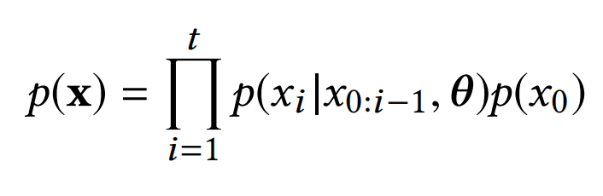

Figure 2: Conditional probability of an item

Next, K proposes to use an extended 1D convolutional neural network (CNN) to model the conditional distribution of user item interaction, as shown in Figure 3 (b). Compared with the standard CNN (Figure 3 (a)), the extended convolutional neural network uses the convolutional operation of "l-dialated convolution" to obtain a larger receptive field without introducing more parameters. This enables the network to better capture long-range dependencies in input data.

Figure 3: Conditional distribution prediction

## Technology

Hardware includes: computer (GPU: NVIDIA RTX2070S, RAM: 500G), software includes: deep learning framework: TensorFlow, programming language: Python 3.9, editor: PyCharm3.3, data preprocessing tool: MySQL.

## Testing and Evaluation Plan

## 3.3.1 Data Testing

Check if the data type is correct and ensure that the data format meets expectations. (For example, for the Yoochoosebuys dataset, there should be four columns, namely: session id: token, item_id: token, count: float, timestamp: float)

Ensure the quality and consistency of the dataset. Check if the data is complete and if there are any missing or abnormal values.

Data preprocessing, the dataset used this time comes from the preprocessed dataset provided by Rebole.

## 3.3.2 Model Testing

Pre train Testing:

Environmental configuration testing: Ensure that the RecBole framework is installed and configured correctly on your system.

Input data format test: Ensure that the dataset can be loaded correctly into the NextItNet model.

Post train Testing:

Data transformation test: Transform input data (such as data augmentation, noise injection, etc.) to check the robustness of the model to data transformation.

Performance evaluation:

Recommendation performance indicators: Use appropriate indicators (such as accuracy, recall, F1 value, etc.) to evaluate and compare the recommendation performance of the model on different datasets.

Resource utilization evaluation: measures the computational resource consumption of the model, such as runtime, memory usage, etc.

## Design and Implementation

In terms of research topic, the author has currently completed the understanding of the model of the template model, and after completing the literature review, has gained a new understanding of the field of recommendation models.

In terms of the dataset, the author completed the download and testing of the dataset, as well as the matching between the dataset and the model.

In terms of model implementation, the author has completed the configuration of the environment and learned how to use the Rebole tool to test and train the model. The model used this time, NextItNet, was implemented and tested using Rebole, and the training results on the built-in dataset and YOOCHOOSE were compared.

Model test results

Figure 4 shows the result of quic start using NextItNet on the recoble, which is the training result using the built-in dataset: ml-100k.

Explanation of indicators:

recall@10 (Recall rate): measures how many items users actually like in the top 10 positions of the recommendation list in the model. The calculation method is the ratio of the actual number of recommended favorite items to the total number of favorite items.

mrr@10 (Average reciprocal ranking): measures the average reciprocal of the items actually liked by the highest ranked user in the recommendation list. Countdown is to emphasize items with higher rankings. The calculation method is to take the average of the reciprocal rankings of the items that each user actually likes.

ndcg@10 (Normalized cumulative loss gain): measures the ranking quality of items in the recommended list of the model. For each user, calculate the cumulative gain of each item in the recommendation list, normalize it, and finally take the average to obtain the overall indicator.

hit@10 (Hit rate): measures how many hits the model has in the top 10 recommendations (the items that the user actually likes are in the recommendation list). The calculation method is the ratio of the actual number of recommended favorite items to the total number of hit items.

precision@10 (Accuracy): Measures how many items the model actually likes among the top 10 recommendations. The calculation method is the ratio of the actual number of items recommended and liked by the user to the total number of recommended items.

The results show an average training time of 64 seconds per round, with a training loss of approximately 250. The results on the test set are recall@10 =0.1166, mrr@10 =0.0366, ndcg@10 =0.0548, hit@10 =0.1166, precision@10 =0.0117.

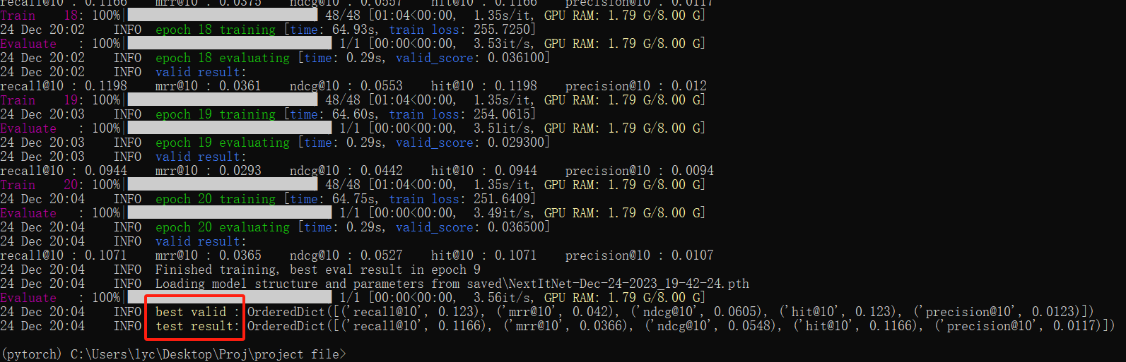

Figure 4: The running results of NextItNet on the built-in dataset

The results of using the yoochoose buy dataset show that the average training time per round is 5 minutes, and the training loss is about 770 seconds. The model performed the best on the validation set in the 19th round, recall@10 : 0.4017, mrr@10 : 0.1626, ndcg@10 : 0.2186, hit@10 : 0.4017, precision@10 : 0.0402. The result of the test set is recall@10 =0.3824, mrr@10 =0.1622, ndcg@10 =0.2139, hit@10 =0.3824, precision@10 =0.0382.(Figure 5 shows the training results, and Figure 6 shows the dataset parameters.)

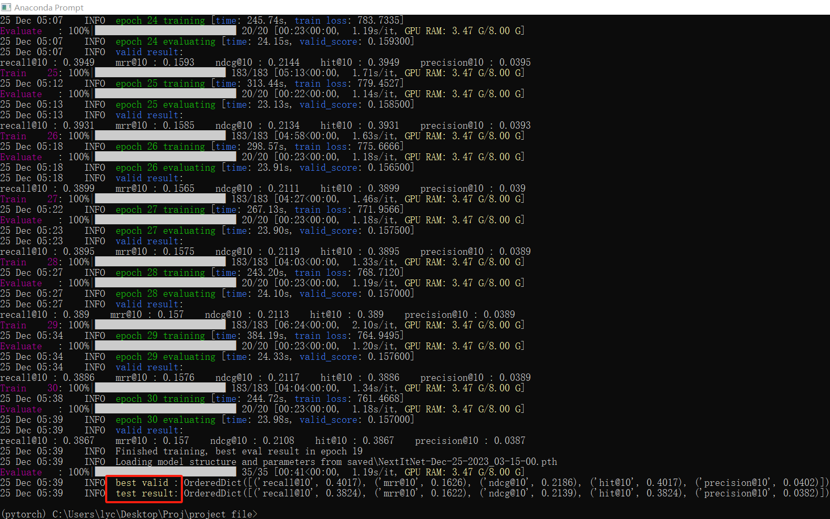

Figure 5: The running results of NextItNet on the yoochoose-buys

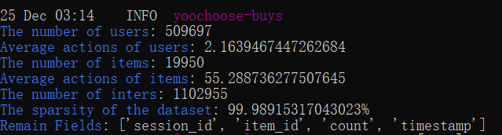

Figure 6: Yoochoose-buy dataset parameters

# Project Management

## Activities

|  |  |
| --- | --- |
| **Objectives** | **Tasks** |
| Collection of relevant literature | Read at least 20 articles in relevant fields, select and take notes |
| Project Proposal | Complete the proposal with clear structure and logic, including a reference list |
| Understanding models and mathematical methods | Analyze and compare the differences between models and interpret relevant methods |
| Improved model | According to the shortcomings of the existing model, search for possible improved technologies and methods through the literature |
| Experimental data processing | According to relevant research fields, the data set was searched and preprocessed |
| Experiment and Test | The model was implemented by code and applied to the dataset, trial and error |
| Summary | Analyze and summarize the experimental results to reach a conclusion, and complete the remaining writing |
| Paper Modify | Revise the format and improve the article |
| Presentation Prepare | Prepare PPT and review research work |

Table 1: Activities

## Schedule

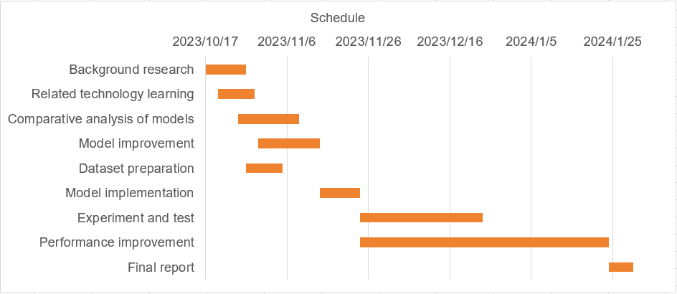

Figure 7: Gantt chart of thesis plan

## Project Version Management

Use the Git repository and Feishu to manage project code or multiple versions of models that have been developed. The code will continue to be updated on Github's personal homepage, and backup management will also be carried out every time it is submitted through Flybook to facilitate subsequent changes.

## Project Data Management

This article uses Zotero to manage relevant literature, including storing the literature in the Zotero manager and annotating and taking notes on each literature, making it easy to quickly search for the desired literature. For code files and dataset files, the code files will be uploaded to a personal account through Github for backup, and each version and date will be classified. Finally, regarding report file management, literature will be stored in cloud documents through the use of WPS office.

|  |  |
| --- | --- |
| Literature management | Zotero |
| Code management | Github |
| Report management | WPS office |

Table 2: Management

## Project Deliverables

|  |  |
| --- | --- |
| Project Resources | Deadline |
| weekly reports | Every week from the fourth week of the first semester |
| Project proposal, ethic form, plagiarism report | November 3, 2023 |
| Progress Report | December 22, 2023 |
| final report | April 12, 2024 |
| presentation poster, video, and demo | May 29th to 31st, 2024 |
| Tech Show | June 6th -7th, 2024 |

Table 3: Resources and Submission Date

# Professional Issues and Risk

## Risk Analysis

In the previous progress, there was a risk of missing the deadline, which occurred on December 18, 2023. Due to tight schedules in other disciplines, students reported to the supervisor in a unified manner. The supervisor decided to postpone the deadline for the progress report to December 27. This risk was resolved by reporting and communicating with the supervisor in advance. Another risk is environmental configuration and tool installation issues. I encountered many problems while installing Rebole, including downloading errors in the PyTorch version, mismatch between the PyTorch version and the Cuda version, incompatibility between PyTorch and the Cuda and Python versions, and very slow installation speed of Rebole. The first few problems were solved by searching a large amount of information on websites such as CSDN and spending a lot of time, The latter's network and device issues are resolved under the patient guidance of the supervisor. For future risks that may involve data loss, regular use of the Git tool for backup will be adopted.

## 

Table 4: Resources and Submission Date

## 5.2 Professional Issues

## 5.2.1 Legal issues

Privacy regulations: The recommendation system used this time will use datasets and involve the processing of user data, so it is necessary to ensure compliance with privacy regulations such as GDPR (European General Data Protection Regulations) or similar regulations in other countries/regions, and BCS's Code of Computer Conduct emphasizes the principles of protecting privacy and legitimate use of information.

Intellectual Property: This project uses publicly available datasets, algorithms, and code from others, and it is necessary to ensure compliance with relevant intellectual property regulations, such as ACM's Code of Ethics, which involves the principles of legitimate use of computing resources and respect for privacy.

## 5.2.2 Social issues

Social impact: My recommendation system may affect the sales of merchants, as recommended products are more likely to be purchased. This may lead to some small businesses losing competitiveness due to a lack of exposure, while large businesses will benefit more. Referring to the ACM Code of Professional Ethics, it is necessary to be aware of the broad impact of the computing profession on society and consider the long-term interests of society when designing recommendation systems. Ensure that the design of the system does not cause undue harm to specific individuals or groups.

## 5.2.3 Ethical issues

Transparency and interpretability: BCS's Code of Computer Conduct involves ethical principles, including transparency and respect for user choices. The model of a recommendation system is usually not publicly available, and it is necessary to consider how to improve transparency and interpretability so that users can understand why they receive specific recommendations.

## 5.2.4 Environmental issues

Energy consumption: My model may require a large amount of computing resources and may have negative impacts on the environment. BCS's Code of Computer Conduct emphasizes the responsibility of using resources, including energy consumption. Therefore, while considering the performance of the recommended model, resource consumption and cost issues should also be considered.

## 

# References

[1] F. Yuan, A. Karatzoglou, I. Arapakis, J. M. Jose, and X. He, ‘A Simple Convolutional Generative Network for Next Item Recommendation’. arXiv, Nov. 28, 2018. Accessed: Oct. 27, 2023. [Online]. Available: http://arxiv.org/abs/1808.05163

[2] C. Cheng, H. Yang, M. R. Lyu, and I. King, ‘Where You Like to Go Next: Successive Point-of-Interest Recommendation’.

[3] X. He and T.-S. Chua, ‘Neural Factorization Machines for Sparse Predictive Analytics’. arXiv, Aug. 16, 2017. Accessed: Oct. 27, 2023. [Online]. Available: http://arxiv.org/abs/1708.05027

[4] B. Hidasi, A. Karatzoglou, L. Baltrunas, and D. Tikk, ‘Session-based Recommendations with Recurrent Neural Networks’. arXiv, Mar. 29, 2016. Accessed: Oct. 27, 2023. [Online]. Available: http://arxiv.org/abs/1511.06939

[5] J. Tang and K. Wang, ‘Personalized Top-N Sequential Recommendation via Convolutional Sequence Embedding’. arXiv, Sep. 19, 2018. Accessed: Oct. 27, 2023. [Online]. Available: http://arxiv.org/abs/1809.07426

[6] W. Song, S. Wang, Y. Wang, and S. Wang, ‘Next-item Recommendations in Short Sessions’. arXiv, Jul. 20, 2021. doi: 10.48550/arXiv.2107.07453.

[7] D. Chai, L. Wang, K. Chen, and Q. Yang, ‘Secure Federated Matrix Factorization’, *IEEE Intell. Syst.*, vol. 36, no. 5, pp. 11–20, Sep. 2021, doi: 10.1109/MIS.2020.3014880.

[8] Z. Li, G. Long, and T. Zhou, ‘Federated Recommendation with Additive Personalization’. arXiv, May 17, 2023. doi: 10.48550/arXiv.2301.09109.

[9] C. Kumar and M. Kumar, ‘Next-item recommendation within a short session using the combined features of horizontal and vertical convolutional neural network’, *Multimed. Tools Appl.*, 2023, doi: 10.1007/s11042-023-17201-z.